The 2022-2023 Hattiesburg Public Schools (HPS) Student Registration windows are:

- June 1, 2022 - July 29, 2022
  - Returning HPS Students Grades K-12 With and Without Address Changes
  - New HPS Students Grades K-12 Not Requesting Affidavits
- July 18, 2022 - July 29, 2022
  - New HPS Students Grades K-12 Requesting Affidavits
  - Returning HPS Students Grades K-12 Requesting Affidavits

Hattiesburg Public Schools uses the online registration process available via ActiveParent. Many families already have existing ActiveParent accounts; however, those families without ActiveParent accounts must set up accounts in order to complete student registration and enrollment. HPS families have the ability to scan and upload registration documents directly into the ActiveParent system for school site review and final verification. To use this feature, parents must have access to a computer scanner or camera from an electronic device/smartphone to use to upload the documents.

To access the HPS ActiveParent online portal, visit the website link: https://mshattiesburg.activeparent.net/Login.aspx?ReturnUrl=%2fDefault.aspx.

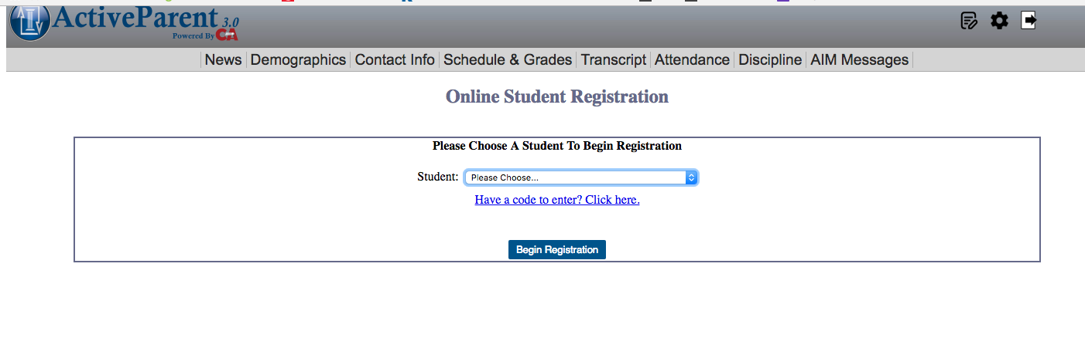

If you are the parent/guardian of a 2022-2023 Returning HPS Student Without Address Change, go to the HPS ActiveParent online portal and start the 2022-2023 online registration process; click the pen/pad icon in the upper right hand corner of the ActiveParent page, enter your account login credentials, and ensure that the upcoming year 2022-2023 is selected. Follow the instructions and complete all student and family information accurately; you must scan and upload into your account at least two current, accurate proofs of residency and immunization records (incoming 7th graders and kindergarteners).

Be mindful to enter and verify the correct home address to ensure the accuracy of your child’s bus assignment. After you complete the online ActiveParent registration process, you may come to your child’s school for next steps and contact your child’s school to confirm that your uploaded proofs have been approved and your registration has been processed and finalized by the school. Note: Additional details regarding transportation and student class schedules are forthcoming.

If you are a parent/guardian who has forgotten your ActiveParent Parent, select “Forgot Password” to reset your password. However, if you have forgotten your ActiveParent User Name, do not create another account; contact your student’s school to recover your ActiveParent account User Name.

If you are the parent/guardian of a 2022-2023 New HPS Student, Incoming Kindergarten HPS Student, or Any HPS Student Without an ActiveParent Account, come to your child’s school to begin the registration process by having your ActiveParent online student ActiveCode created Monday - Friday during the hours of 8:30 a.m. - 3:00 p.m. After you receive an ActiveCode from your child’s school, go to the HPS ActiveParent online portal, click “Create ActiveParent Account” and enter the required information with the school-provided 12-digit ActiveCode; then click the pen/pad icon in the upper right hand corner of the ActiveParent page ensuring that the upcoming year 2022-2023 is selected.
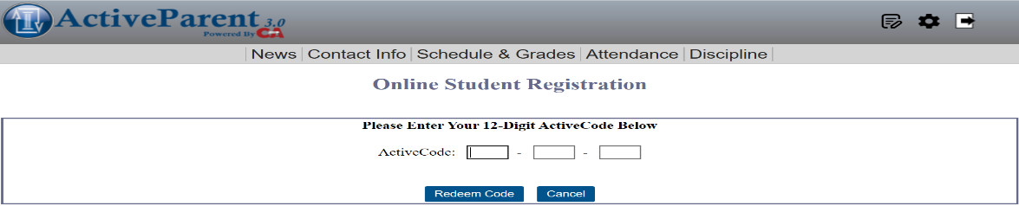
If you are the parent/guardian of a 2022-2023 Returning HPS Student With a New Address, Returning HPS Student Requesting an Affidavit, or New HPS Student Requesting an Affidavit, come to your child’s school to begin the registration process in-person Monday - Friday during the hours of 8:30 a.m. - 3:00 p.m. Note: For all individuals requesting affidavits, both the parent/guardian of the registering student and the owner/lease holder of the home must come in-person together to the school site with the appropriate documents (i.e. two proofs of residency documents, valid/state issued identification, etc.).

For the 2022-2023 school year, all Hattiesburg Public Schools families grades K-12 must provide updated copies of at least two clearly legible and accurate approved proofs of residency and a government issued form of identification.
Examples of Approved Proofs of Residency include:
- Filed Homestead Exemption Application form
- Mortgage documents or property deed
- Apartment/home lease/rental agreement (must be current) *Note: any unofficial lease agreement handwritten or computer-generated must be notarized.
- Current Utility Bill
- Examples of Acceptable bills as proofs: electricity, gas, water, landline telephone, cable TV or satellite TV
- Driver’s license or voter identification (must match an approved proof of residence)
- *Not Acceptable as Proof of Residency: cellular phone bill

Hattiesburg Public Schools would like to ensure a successful 2022-2023 registration experience for our students and families. It truly takes all of us working together to build greatness and to ensure the education of all students.

For registration questions and additional information, contact your child’s school.
Grace Christian Elementary School 601-583-0662
Hawkins Elementary School 601-583-4311
Rowan Elementary School 601-583-0960
Thames Elementary School 601-582-6655
Woodley Elementary School 601-583-8112
Hattiesburg STEAM Academy 601-582-5291
N.R. Burger Middle School 601-582-0536
Hattiesburg High School 601-544-0811
Lillie Burney Learning Center 601-584-6311

